Cover Page
SQL DATA ANALYSIS
Project 3
Industrial Training Kit
Submitted By
Harshath Mohammad
Submitted To
DecodeLabs
Batch: 2026

Contents
Introduction 3
Objectives 3
Tools and Technologies Used 3
Dataset Description 3
Database Creation and Data Import 4
SQL Queries and Results 5
Key Findings 8
Conclusion 8

Introduction
SQL (Structured Query Language) is the standard language used to interact with relational databases. It allows users to retrieve, filter, sort, group, and analyze data efficiently. In this project, SQL was used to analyze an e-commerce sales dataset imported into MySQL. Various SQL queries were executed to generate business insights, including filtering records, sorting data, grouping information, and performing aggregate calculations such as COUNT(), SUM(), and AVG().

Objectives
- Learn the fundamentals of SQL.
- Retrieve data using SELECT statements.
- Filter records using the WHERE clause.
- Sort data using ORDER BY.
- Group records using GROUP BY.
- Perform aggregate calculations using COUNT(), SUM(), and AVG().
- Generate meaningful business insights from an e-commerce sales dataset.

Tools and Technologies Used
Tool | Purpose
MySQL Server 8.0 | Database management
MySQL Workbench | SQL query execution
Microsoft Excel | Dataset preparation
Git | Version control
GitHub | Project hosting
Microsoft Word | Report preparation

Dataset Description
The dataset contains 1200 records and 14 columns representing e-commerce sales transactions. It includes customer information, product details, payment methods, order status, and sales values. The dataset was imported into MySQL for SQL analysis.

Column | Description
OrderID | Unique order ID
Date | Order date
CustomerID | Customer ID
Product | Product name
Quantity | Quantity purchased
UnitPrice | Price per unit
ShippingAddress | Delivery address
PaymentMethod | Payment method
OrderStatus | Status of the order
TrackingNumber | Tracking ID
ItemsInCart | Number of items in cart
CouponCode | Coupon applied
ReferralSource | Source of customer
TotalPrice | Total order value

Database Creation and Data Import

Database Creation

CREATE DATABASE ecommerce_db;
USE ecommerce_db;

Data Import

The cleaned dataset was converted from Excel (.xlsx) to CSV (.csv) and imported into MySQL using the Table Data Import Wizard in MySQL Workbench. After the import, the data was stored in the ecommerce_sales table for analysis.

SQl coding Screenshots

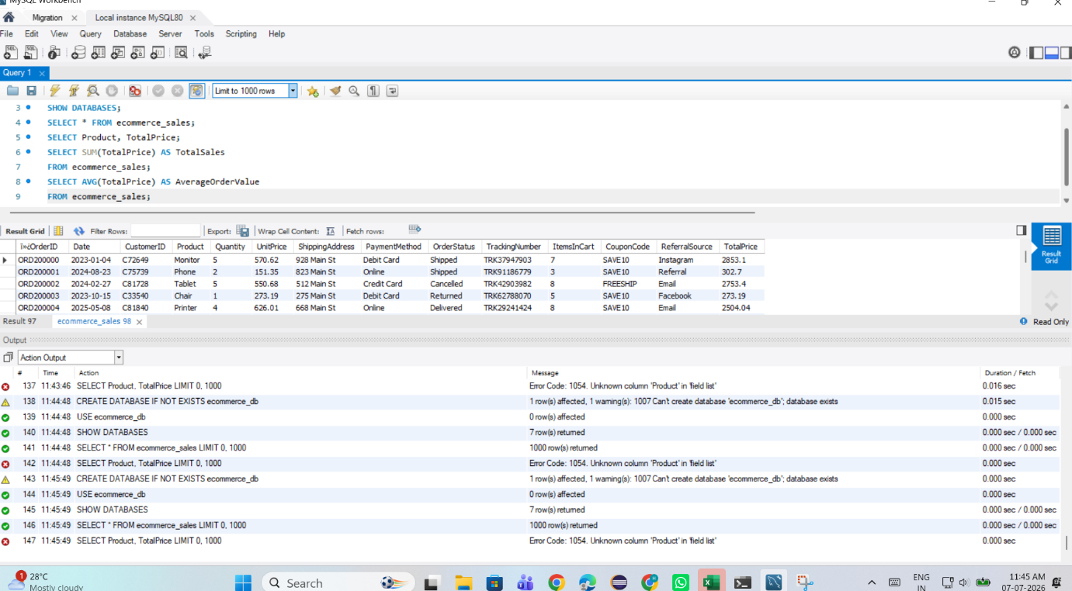
(1)

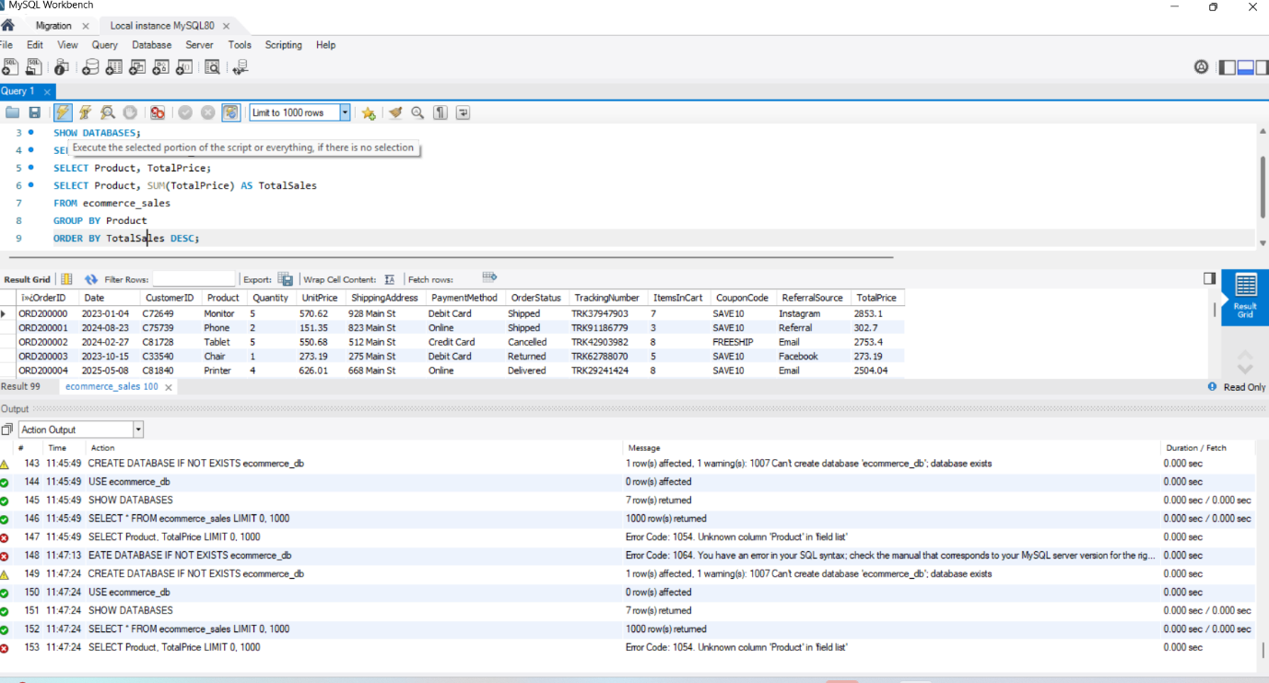
(2)
SQL Queries and Results
6.1 Sort Records Using ORDER BY
SELECT *
FROM ecommerce_sales
ORDER BY TotalPrice DESC;

Description
This query sorts all orders from the highest total price to the lowest
.
6.2 Group Records Using GROUP BY
SELECT Product,
COUNT(*) AS TotalOrders
FROM ecommerce_sales
GROUP BY Product;
Description
This query counts the number of orders for each product.

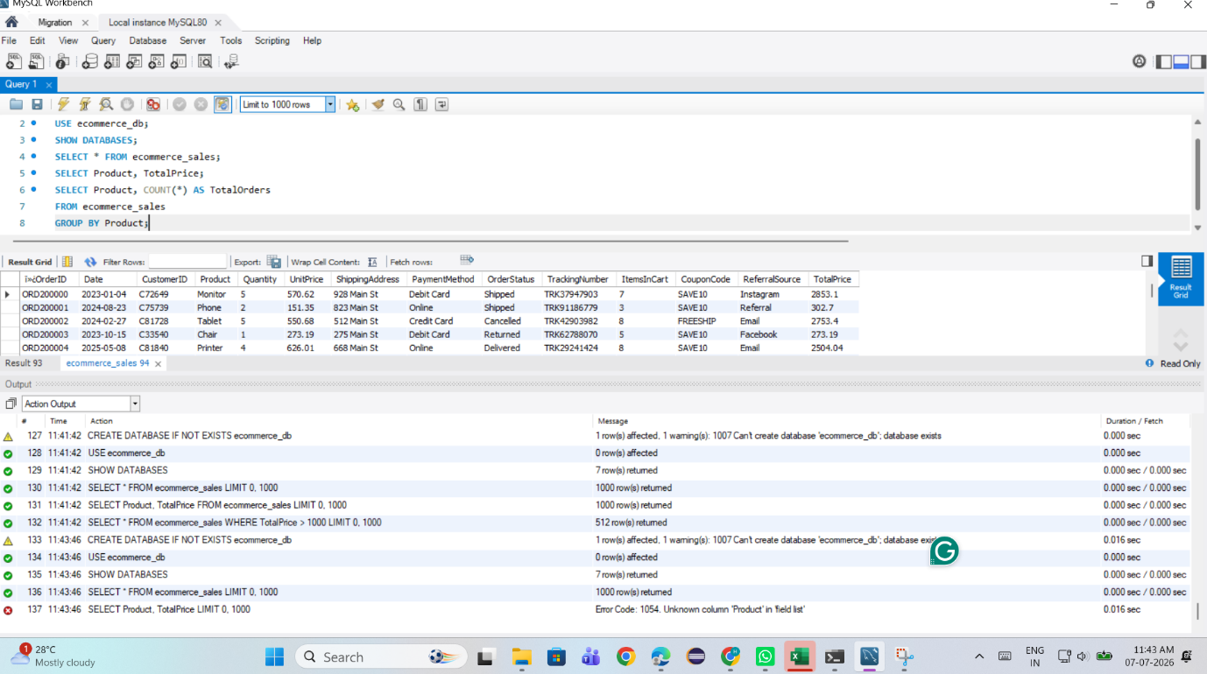
6.3 SUM()
Query
SELECT SUM(TotalPrice) AS TotalSales
FROM ecommerce_sales;
Description
This query calculates the total sales amount from all orders.
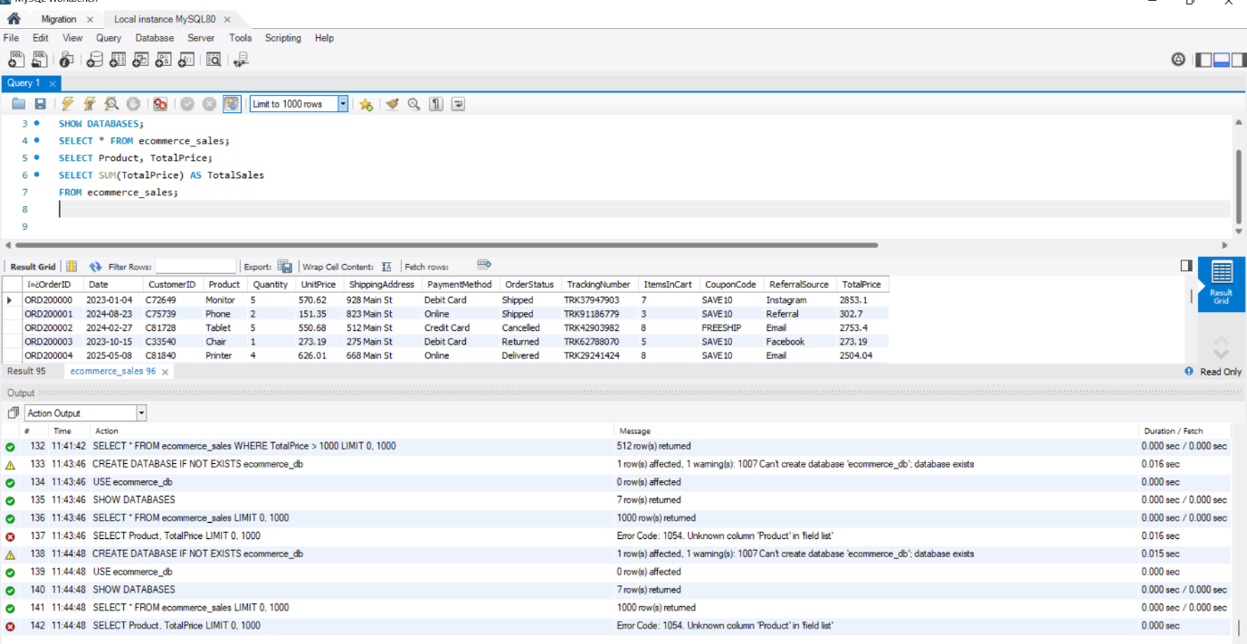

6.4 AVG()
Query
SELECT AVG(TotalPrice) AS AverageOrderValue
FROM ecommerce_sales;
Description
This query calculates the average value of all customer orders.



Key Findings
- The dataset contains 1200 e-commerce transactions.
- SQL was successfully used to retrieve, filter, sort, and group data.
- Aggregate functions (COUNT, SUM, and AVG) provided meaningful business metrics.
- Product-wise sales analysis identified the distribution of orders across products.
- Payment method analysis showed customer purchasing preferences.
- Referral source analysis highlighted the channels bringing customers to the platform.
- SQL enables efficient extraction of insights from relational databases.
Conclusion
This project demonstrated the practical use of SQL for analyzing an e-commerce sales dataset. By applying SQL concepts such as SELECT, WHERE, ORDER BY, GROUP BY, COUNT(), SUM(), and AVG(), meaningful business insights were generated from raw transactional data. The project strengthened my understanding of database querying and data analysis, while also improving my ability to organize and interpret information stored in relational databases.
References
- MySQL Documentation
- MySQL Workbench
- Microsoft Excel Documentation
- DecodeLabs Industrial Training Kit

